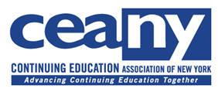
Region East Meeting
May 4, 2018
Herkimer College
Robert McLaughlin College Center, room 282/283
Agenda

9:30 – Sign in, Morning Refreshments
10:00 a.m. – Herkimer College Welcome: President, Dr. Cathleen McColgin
10:05 a.m. – CEANY Welcome: President, Jill Pippin
10:15 a.m. – Educational Opportunity Centers: Student Empowerment, Developmental
Education and Middle Skill Sets

*Susan C. Perkins, Ph.D., Director of Programs and Services, University Center for Academic and Workforce Development (UCAWD), SUNY System Administration
11:30 a.m. – Exploring Micro-Credentials and Badges
* Jill Pippin, Dean of Extended Learning, SUNY Oswego; CEANY President
12:30 p.m. – Lunch Served
1:00 p.m. – Round table Sharing and Networking
2:00 p.m. – Closing Remarks – Jill Pippin, Carolyn DeJohn

